National Marine Aquarium

Personal Meaning Mapping Software

USER MANUAL

Contents

Android Drawing App 2

Setting up the tablet for an event 2

Launch Screen 2

Drawing Canvas 2

Save Image 4

Upload Screen 5

Admin Portal Application 6

Users 6

Adding a User 6

Editing orDeleting a User 6

Dashboard 7

Events 8

Locations 8

Creating an Event or a Location 9

Editing or Deleting an Event or a Location 9

Scoring a Drawing 10

Breadth 10

Depth and Extent 11

# Android Drawing App

## Setting up the tablet for an event

### Launch Screen

When launching the app, you will be presented with a screen allowing you to enter the event code. The event code can be found through the admin app (see page 8)

This screen also allows you to view all the pictures that have yet to be uploaded by pressing the upload button (see page 5)

### Drawing Canvas

After entering the event code, you will be taken directly to the drawing canvas.

The canvas has been designed in such a way that those that use it should only recognise the icons relevant to their experience with drawing on touch screen devices and you should not need to explain the functions or layout to the visitor.

The buttons are as follows:

1. Colour selection (for all ages and experience)
2. Stroke width (for the slightly more experienced)
3. Eraser
4. Line Draw
5. Fill Draw
6. Save Image

#### Colour Selection

Here, by tapping the colour, the pen will change to the colour selected and the selected colour is represented by this icon:

#### Stroke Width

These icons represent the width of the pen. To the left is the thinnest, to the right the largest. The default is the medium width.

#### Eraser

Selecting the eraser will allow the user to erase part of their drawing and works exactly the same as the pen, and also the Stroke width, only the eraser will match the background colour.

#### Line Draw

This is the default option and will draw a simple straight line that will follow the users input.

#### Fill Draw

As the user draws a shape with their finger, this will fill the shape as it is drawn.

#### Save Image

This will bring up the save image dialogue (see below)

### Save Image

This screen allows the visitor to enter their name and age to be saved with the drawing.

If the user enters their full name, any name after the first name will be disregarded and only their first name will be recorded alongside the drawing. The age field will only allow ages from (1 – 120) to be entered. If either box is left empty, or an invalid age is entered, the following warnings will appear:

Should either of these warnings appear, correct information will need to be entered before the user can continue.

Once the details are correct, the user can press the save button and save their drawing. The screen will then return to the drawing canvas, ready for the next visitor.

### Upload Screen

This screen will display all the drawings that have yet to be uploaded. They will be separated by event ID.

Any drawings that are unselected here will be marked as zero score, so obvious scribblings, blank drawings, etc. These drawing will then not appear to be scored in the scoring application.

# Admin Portal Application

## Users

### Adding a User

To add a user, simply click “Add user on the home screen and enter the new users name in the text box.

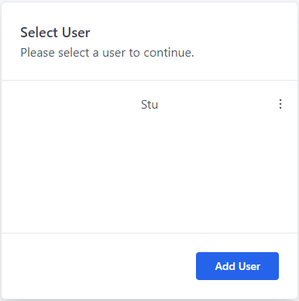

### Editing orDeleting a User

To edit a user, click the three dots next to a user’s name, here you can then edit the username of the user.

You will then be taken to the User editing/deleting view.

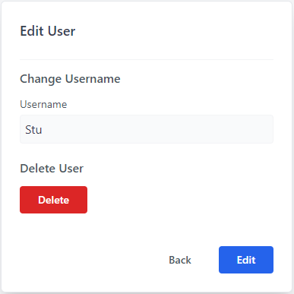

Here, you can edit the username of the user, or delete the user.

## Dashboard

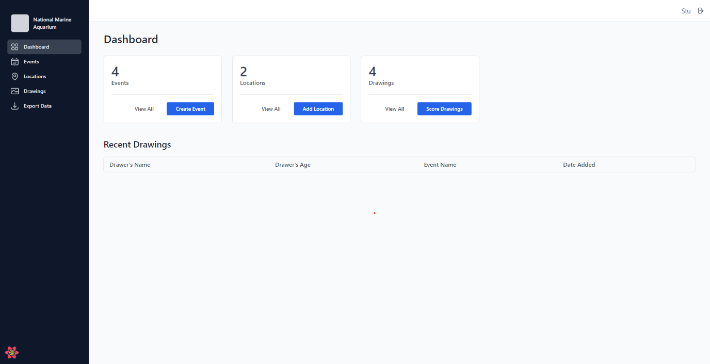

This is the Dashboard you will be greeted with after selecting a user. From here you can navigate to Events, Locations, and Drawings from the navigation pane on the left. You can also add events, locations and score drawings directly from this dashboard by clicking the relevant buttons.

## Events

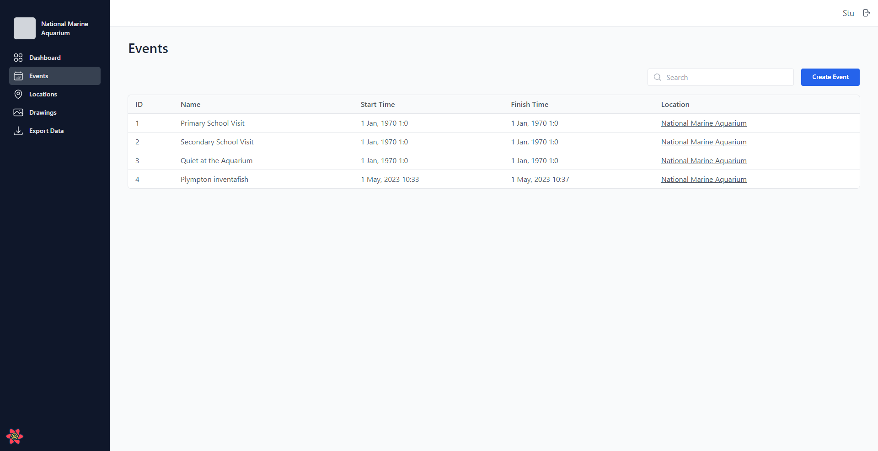

This is the Events View. From here you can select an event to view the details. For more details, see Adding, Editing or Creating on page x

## Locations

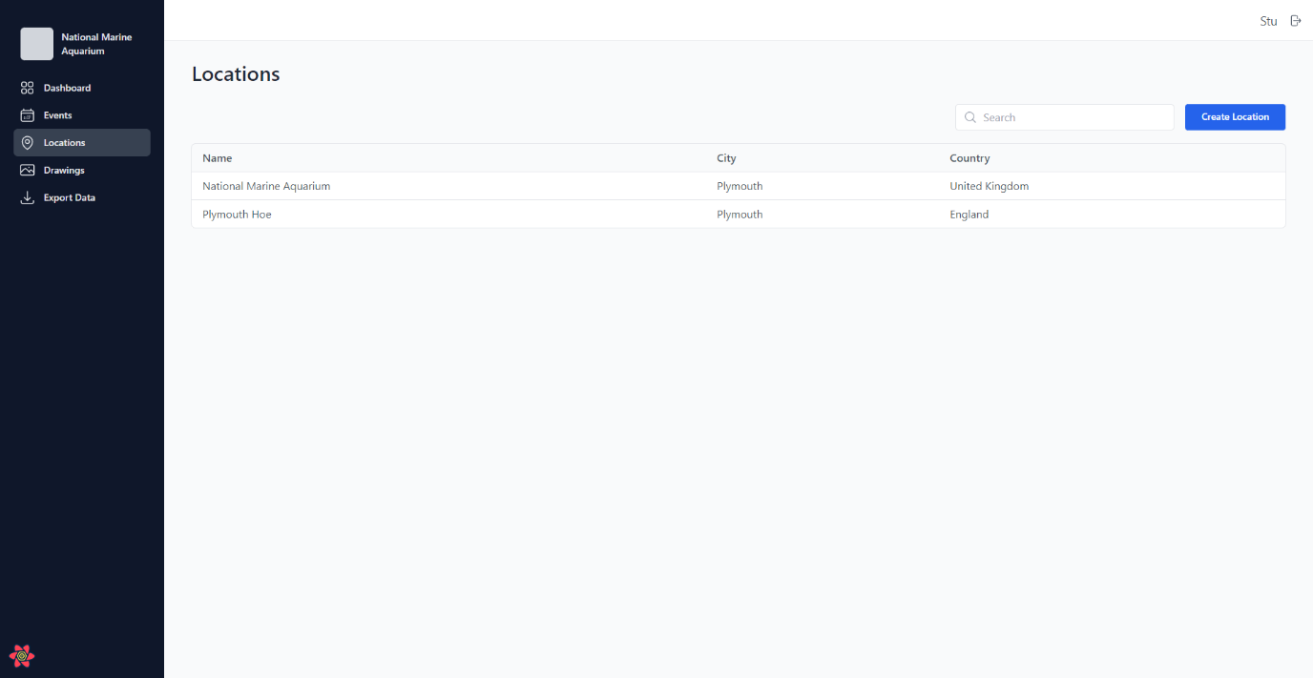

This is the Locations View. From here you can select a location to view the details. For more details, see Adding, Editing or Creating on page x

## Creating an Event or a Location

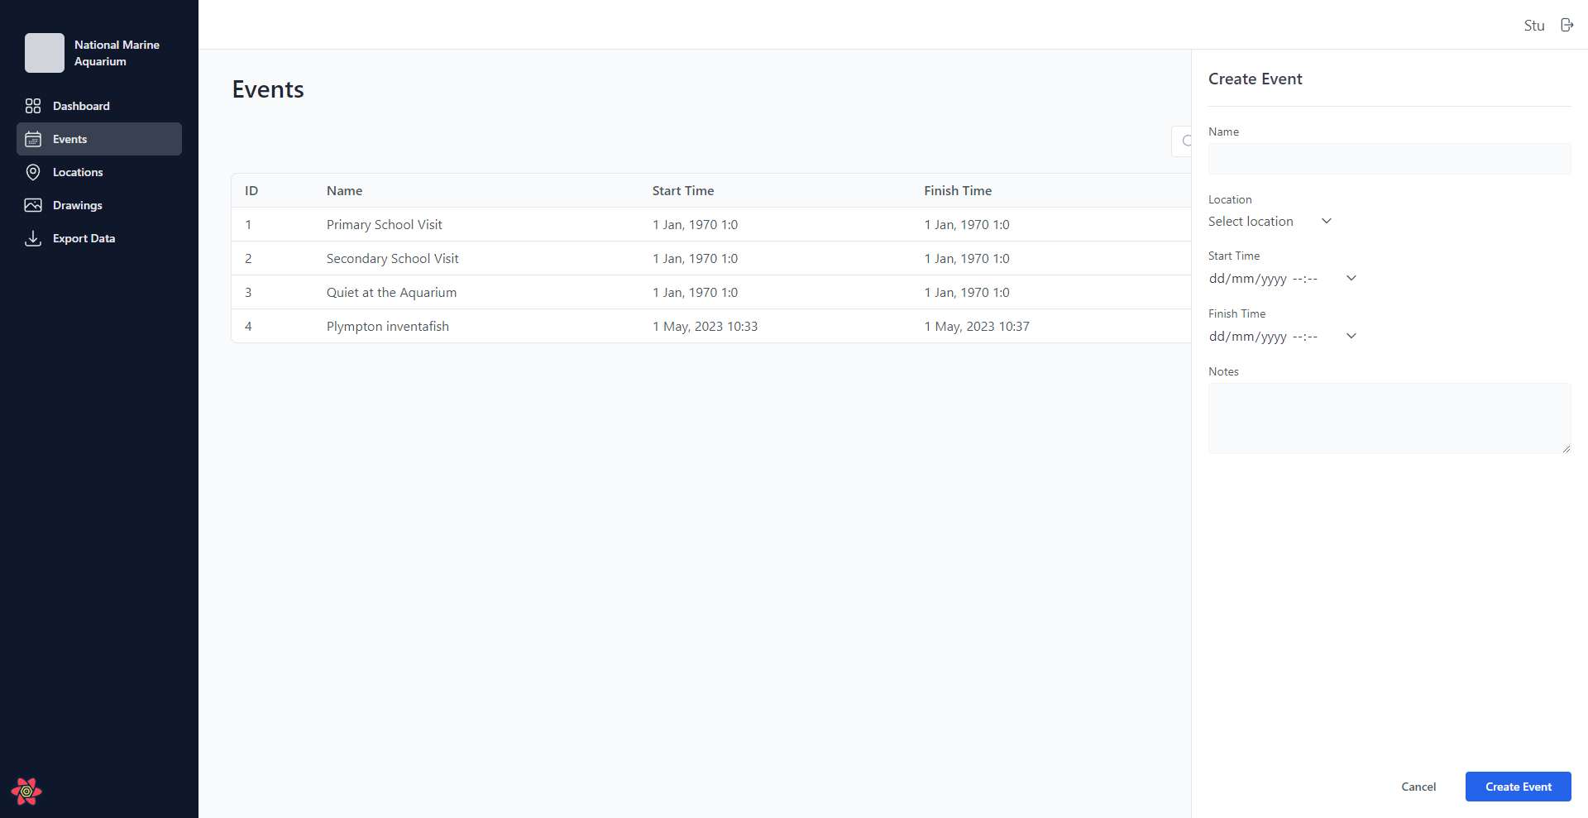

By clicking “Create Event” or “Add Location”, the relevant create pane will slide out from the right of the screen. From here you can enter the relevant details of the Location or Event.

## Editing or Deleting an Event or a Location

Upon Clicking an Event or Location, the details will appear in a pane on the right of the screen. From here, click the three dots highlighted above by a blue circle.

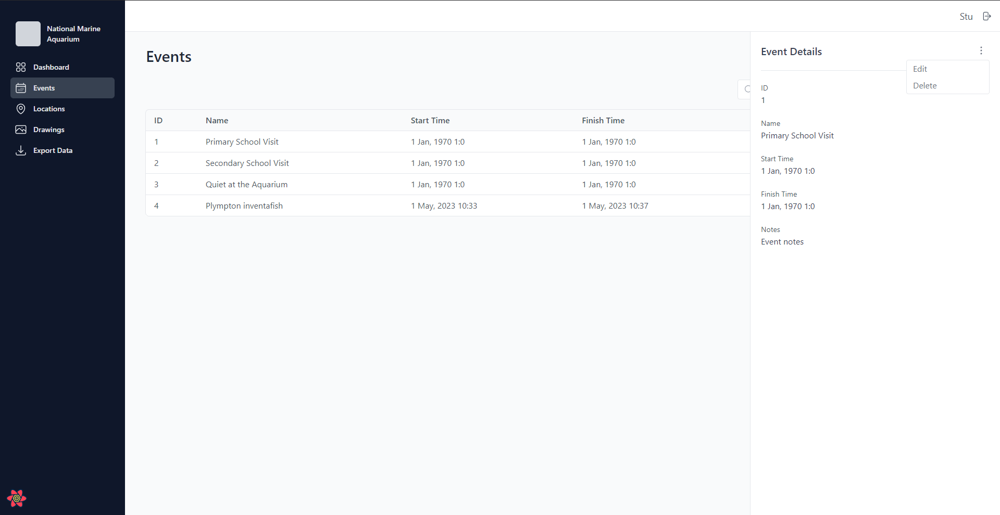

You will then be given the option to Edit or Delete the selected Event/Location. Selecting Delete will delete the Event/Location. Selecting Edit will enable editing of the fields.

## Scoring a Drawing

### Breadth

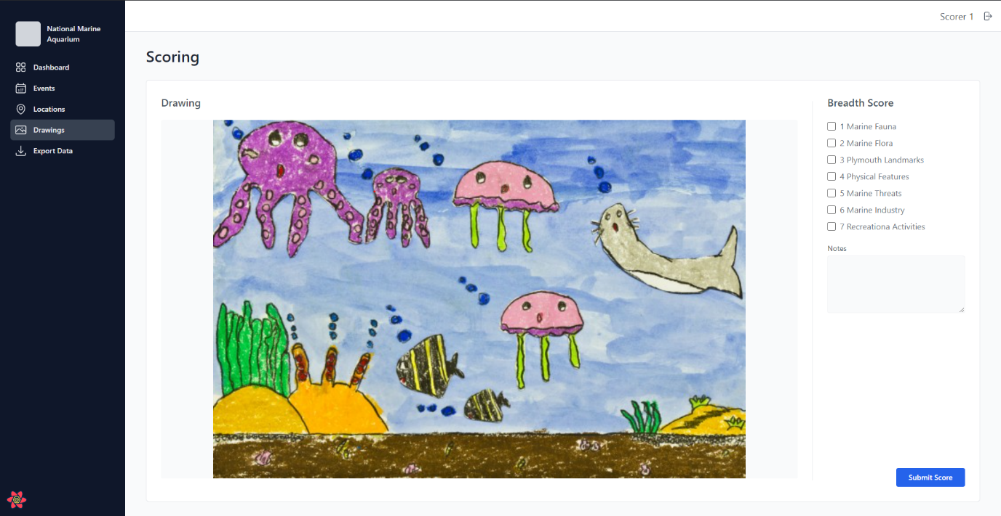

To score the Breadth of a drawing, select the tick boxes next to the relevant Themes that are contained in the drawing. There is also the opportunity to provide notes on the drawing with regards to the Breadth on this screen.

### Depth and Extent

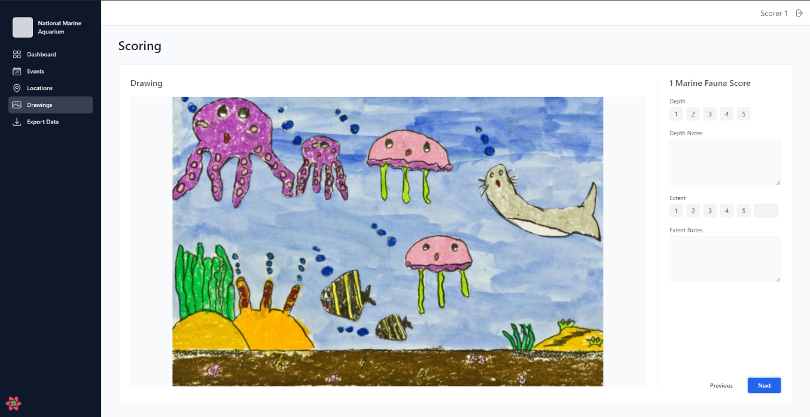

To score the Depth, select the score of one to five. There is also the opportunity to add notes relevant to the depth score here.

To score the Extent, either select the score of one to five. If the Extent score for the theme is more than 5, you can enter the score in the box to the right of five. There is also the opportunity to add notes relevant to the extent score here.

After scoring for the first theme, if more than one theme was selected in the Depth score, you will be taken to the next topic for the drawing and you can then enter the relevant depth and extent scores for the next theme contained on the drawing. This will repeat until all themes are scored.